
Sarbanam Shikshyalaya
Gokarneshwor-06 Jorpati, Kathmandu
Final Terminal Examination-2079
Grade: LKG F.M:50
Subject: Art P.M:20 Time: 1:15 hrs.
Name: Section: Roll. No:

Marks Obtained Sheet
Q.N. | O.M. | Q.N. | O.M. | Q.N. | O.M. | Q.N. | O.M. | Q.N. | O.M.
1. |  | 2. |  | 3. |  | 4. |  | 5.
6. |  | 7. |  | 8. |  | 9. |  | 10.
11. |  | 12. |  | 13. |  | 14. |  | 15.
16. |  | 17. |  | 18. |  | 19. |  | 20.

Total:
In words:

-------------- ---------------- ------------------ ------------------------Invigilator Examiner Checked By Exam Coordinator

- Write the name of any 5 colors. (5)
- ________________________
- ________________________
- ________________________
- ________________________
- ________________________
- Draw the following shapes and color them. (5)

- Join the dots and complete the pictures. (10)
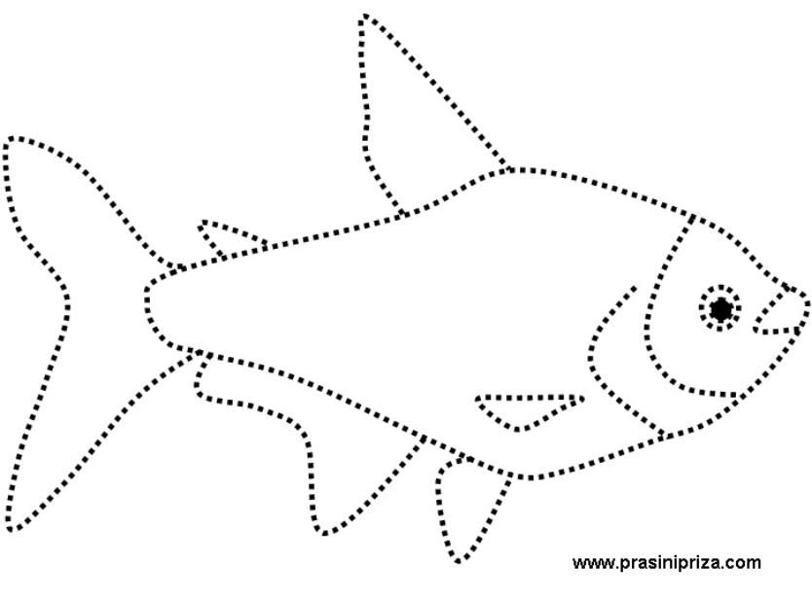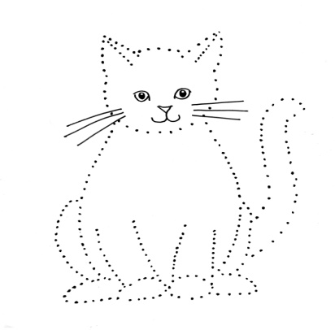

- Draw the pictures of following names. (10)
Umbrella | Sun

- Copy the same picture. (5)



____________________________

- Class Test. (5)
- Handwriting. (2)
- Oral. (2)
- Assignment. (2)
- Discipline. (2)
- Regularity. (2)

THE END

Sarbanam Shikshyalaya
Gokarneshwor-06 Jorpati, Kathmandu
Final Examination-2079
Grade: LKG F.M:50
Subject: Conversation P.M:20 Time: 1:15 hrs.
Name: Section: Roll. No:

Marks Obtained Sheet
Q.N. | O.M. | Q.N. | O.M. | Q.N. | O.M. | Q.N. | O.M. | Q.N. | O.M.
1. |  | 2. |  | 3. |  | 4. |  | 5.
6. |  | 7. |  | 8. |  | 9. |  | 10.
11. |  | 12. |  | 13. |  | 14. |  | 15.
16. |  | 17. |  | 18. |  | 19. |  | 20.

Total:
In words:

-------------- ---------------- ------------------ ------------------------Invigilator Examiner Checked By Exam Coordinator

- Short question answer. (10)
- Do you love your parents?
Ans:____________________________________________________
- Do you like healthy food?
Ans:____________________________________________________
- Do you do your homework yourself?
Ans:____________________________________________________
- Do you have sister?
Ans:____________________________________________________
- Do you know which day is today?
Ans:____________________________________________________
- Do you know your friend’s name?
Ans:____________________________________________________
- Do you know your class teacher’s name?
Ans: ___________________________________________________
- Do you obey your parents?
Ans: ____________________________________________________
- Do you like to eat dal, vaat and tarkari?
Ans: ____________________________________________________

- Do you like reading and writing?
Ans: ____________________________________________________
- Long question answer. (20)
- What is your name?
Ans: ____________________________________________________
- In which class do you read?
Ans: ____________________________________________________
- What is your school’s name?
Ans: ____________________________________________________
- What is your principal’s name?
Ans: ____________________________________________________
- What is your class teacher’s name?
Ans: ___________________________________________________
- Where do you live??
Ans: ____________________________________________________
- How old are you?
Ans: ____________________________________________________
- What is your father’s name?
Ans: ____________________________________________________

- What is your mother’s name?
Ans: ____________________________________________________
- What is the name of our country?
Ans: ____________________________________________________
- Tell the spelling of the following words. (5)
- Grapes: ____________________________________________________
- Book: ____________________________________________________
- Pen: ____________________________________________________
- Copy: ____________________________________________________
- Cow: ____________________________________________________

- Tell about yourself. (10)

- Class Test. (5)

THE END

Sarbanam Shikshyalaya
Gokarneshwor-06 Jorpati, Kathmandu
Final Examination-2079
Grade: LKG F.M:100
Subject: English P.M:40 Time: 2:30 hrs.
Name: Section: Roll. No:

Marks Obtained Sheet
Q.N. | O.M. | Q.N. | O.M. | Q.N. | O.M. | Q.N. | O.M. | Q.N. | O.M.
1. |  | 2. |  | 3. |  | 4. |  | 5.
6. |  | 7. |  | 8. |  | 9. |  | 10.
11. |  | 12. |  | 13. |  | 14. |  | 15.
16. |  | 17. |  | 18. |  | 19. |  | 20.

Total:
In words:

-------------- ---------------- ------------------ ------------------------
Invigilator Examiner Checked By Exam Coordinator

- Answer the following questions. (10)
- What is your name?
Ans: My name is _______________________________ .
- In which class do you read?
Ans: I read in class ________________________________.
- How old are you?
Ans: I am _______________________ years old.
d. Where do you live?
Ans: I live in _________________________________________.
e. How many days are there in a week?
Ans: There are __________ days in a week.
- Make words from the following letters. (5)
H= ______________ J= ____________
M= ______________ E=________________
B= _____________
- Write the name of 7 days. (7)
- ______________________
- ______________________
- ______________________
- ______________________
- ______________________
- ______________________
- ______________________

- Fill in the missing letters. (5)
- M __ g
- B __ t
- C __ p
- B __ __ k
- C p __

- Write the family words of ‘op’. (5) 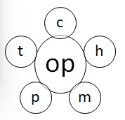
- __________________
- __________________
- __________________
- __________________
- __________________

- Name the given pictures. (8)

______________ ______________
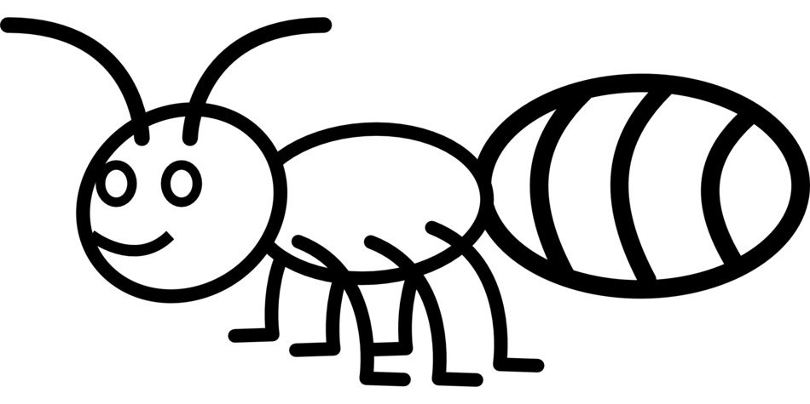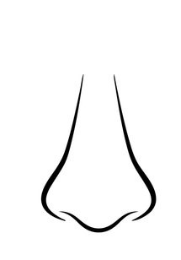
______________ ______________
- Fill in the missing vowel letters. (5)
b c d f g h

j k l m n p

q r s t v w x

y z
- Write down the rhyming words. (5)
- Fun = ______________
- Fat = ______________
- Jug = ______________
- Log = ______________
- Dig = ______________

- Dictation. (5)
- ______________________
- ______________________
- ______________________
- ______________________
- ______________________

- Copy down. (10)
Nose | Hand
- Class Test. (10)
- Handwriting. (5)
- Oral. (5)
- Assignment. (5)
- Discipline. (5)
- Regularity. (5)

Sarbanam Shikshyalaya
Gokarneshwor-06 Jorpati, Kathmandu
Final Examination-2079
Grade: LKG F.M:100
Subject: Math P.M:40 Time: 2:30 hrs.
Name: Section: Roll. No:

Marks Obtained Sheet
Q.N. | O.M. | Q.N. | O.M. | Q.N. | O.M. | Q.N. | O.M. | Q.N. | O.M.
1. |  | 2. |  | 3. |  | 4. |  | 5.
6. |  | 7. |  | 8. |  | 9. |  | 10.
11. |  | 12. |  | 13. |  | 14. |  | 15.
16. |  | 17. |  | 18. |  | 19. |  | 20.

Total:
In words:

-------------- ---------------- ------------------ ------------------------
Invigilator Examiner Checked By Exam Coordinator

- Write down the numbers from 61 to 70. (5)

- Write down the Nepali numbers from @! to #). (5)

- Write in numbers. (5)
- Nine: _____________________
- Eleven: ____________________
- Fifteen: ___________________
- Seventeen: ___________________
- Twenty: __________________

- Count and write the numbers. (5)
= ___________________

= _____________________

= _____________________

= _____________________

= __________________

- Draw the following shapes. (5)
Circle | Heart

- Match the following. (5)
Ten 11
Eleven 10
Fourteen 16
Sixteen 14
Twenty 20
- Join the dots and make the shapes. (5)

- What comes after? (5)
- 30 _________
- 32 _________
- 40 _________
- 45 _________
- 50 _________

- Use <, >, or = sign. (5)

- 3 3
- 8 5
- 7 9
- 10 10
- 15 15

- Addition. (5)
- 2 + 1 = ____________

- 2 + 2 = ______________

- 5 + 3 =______________

- 4 + 1 =______________

- 5 + 5 = ______________

- Copy the following words. (5)
Five Eight Ten

______________ ______________ _____________

Fifteen Twenty

_______________ ____________________

- Count the pictures and circle the correct numbers(10)
- 
4 | 6 | 5

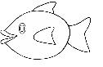

5 | 4 | 6

5 | 8 | 6

6 | 5 | 4

4 | 1 | 7

- Class Test. (10)
- Handwriting. (5)
- Oral. (5)
- Assignment. (5)
- Discipline. (5)
- Regularity. (5)

THE END
;j{gfd lzIffno
uf]s0f]{Zj/-)^,hf]/kf6L
jflif{s k/LIff —@)&(

sIff M Pn=s]hL k"0ff{ª\s M !)) ljifo M g]kfnL pQL0ff{ª\SmM$)
;do : @ M#)3
gfd M ju{ M /f]n g M +
Marks Obtained Sheet
Q.N. | M.O | Q.N. | M.O | Q.N. | M.O | Q.N. | M.O | Q.N. | M.O
1. |  | 2. |  | 3. |  | 4. |  | 5.
6. |  | 7. |  | 8. |  | 9. |  | 10.
11. |  | 12. |  | 13. |  | 14. |  | 15.
16. |  | 17. |  | 18. |  | 19. |  | 20.

Total :
In words:

------------------ --------------- ----------------- -------------------------
Invigilator Examiner Checker Exam Co-ordinator

k|Zg=!= bL3{ psf/ - " _ s" b]lv `" ;Dd n]v . -!)_
k|Zg=@= lbOPsf cIf/af6 zAb agfpm . -%_
s =====================================
v =====================================
u =====================================
3 =====================================
ª =====================================
k|Zg=#= k5f8Lsf] cIf/df bL3{ Osf/ - L _ yk]/ zAb agfpm . -!)_
d; M ================================ wg M================================
v/ M ================================w'k M================================
v; M================================

k|Zg=$= tLg cIf/sf zAbx? n]v . -%_
s_ =====================================
v_ =====================================
u_ =====================================
3_ =====================================
ª_ =====================================

k|Zg=%= cIf/ / lrqsf] hf]8f ldnfpm . -%_

bL
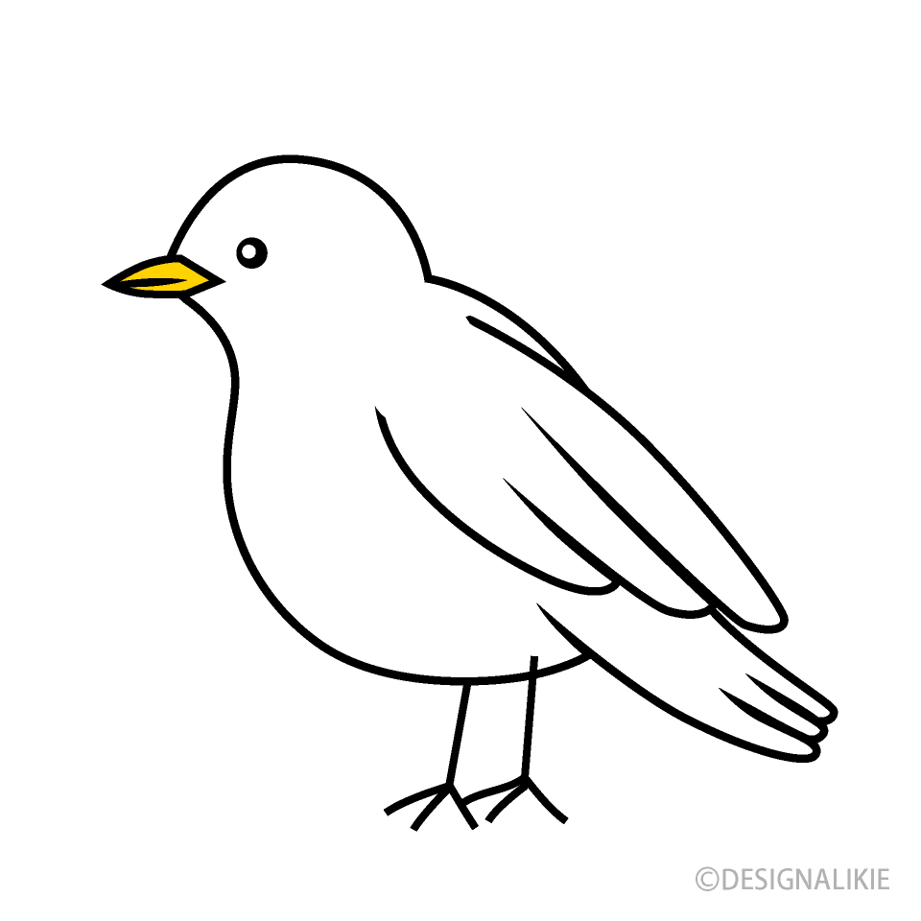
3
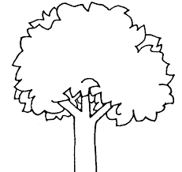
s
r
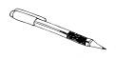
?

k|Zg=^= cIf/ hf]8]/ zAb agfpm . -%_
cf ± df Ö ===========================
r ± /f Ö ===========================
s ± n ± d Ö ===========================
g ± ª Ö ===========================
5f ± tf Ö ===========================

k|Zg=&= tnsf lrqsf] gfd n]v . -%_
================= =======================

================= =======================

= =================================
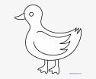
======================================

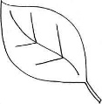
=========================

k|Zg=*= cfsf/ - f _ nfu]sf kfFrj6f zAb n]v . -%_
s_ =====================================
v_ =====================================
u_ =====================================
3_ =====================================
ª_ =====================================
k|Zg=(= gldNg] zAbdf uf]nf] -)_ 3]/f nufpm . -%_
s_ vn vn vn hn
v_ sn ud ud ud
u_ 3/ 3/ gª 3/
3_ 8/ 8/ sk 8/
ª_ rs rs 5n rs

k|Zg=!)= vfnL 7fpF e/ . -%_
s_ s =========== d
v_ va ============
u_ k; ============
3_ 5f ============
ª_ d ============ d
k|Zg=!!= x]/]/ ;f/ . -%_
d eft vfG5' .
===========================================================
===========================================================
===========================================================
===========================================================
===========================================================

k|Zg=!@=PsfO{ k/LIff -!)_
k|Zg=!#=x:tn]vg -%_
k|Zg=!$=u[xsfo{{ -%_
k|Zg=!%=cg'zf;g -%_
k|Zg=!^=lgoldttf -%_
k|Zg=!&=df}lvs pQ/ -%_

Sarbanam Shikshyalaya
Gokarneshwor-06 Jorpati, Kathmandu
Final Examination-2079
Grade: LKG F.M:100
Subject: Science P.M:40 Time: 2:30 hrs.
Name: Section: Roll. No:

Marks Obtained Sheet
Q.N. | O.M. | Q.N. | O.M. | Q.N. | O.M. | Q.N. | O.M. | Q.N. | O.M.
1. |  | 2. |  | 3. |  | 4. |  | 5.
6. |  | 7. |  | 8. |  | 9. |  | 10.
11. |  | 12. |  | 13. |  | 14. |  | 15.
16. |  | 17. |  | 18. |  | 19. |  | 20.

Total:
In words:

-------------- ---------------- ------------------ ------------------------Invigilator Examiner Checked By Exam Coordinator

- Write the name of any 5 living things. (5)
- ____________________________

- ____________________________

- ____________________________

- ____________________________

- ____________________________
- Write the name of any 5 non-living things. (5)
- ____________________________

- ____________________________

- ____________________________

- ____________________________

- ____________________________
- Write the name of any 5 fruits. (10)
a._______________________ d. _______________________
b._______________________ e. _______________________
c.______________________
- Write the name of any 5 land transportation. (10)
- ______________________ d. _____________________
- ______________________ e. ______________________
- ______________________
- Match the following pictures with their names. (5)
 Bird
 Butterfly  Leaf
 House
 Jellyfish
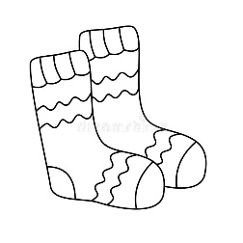

- Name the given pictures. (5)
- b.

___________________ _______________
- Arrange the jumbled letters. (5)
- nat = _________________
- gbu = _________________
- hfis = _________________
- tooph = _________________
- ouhes = __________________
- Fill in the missing letters. (5)
- B _____ ue
- T________ee
- C _____at
- Gi_____l
- B _____s
- Draw the pictures of Ant and Butterfly. (10)
Ant | Butterfly

- Write “G” for good and “B” for bad habits. (5)
- Namaste ! ______________
- Screaming _______________
- Touch Sharp things _______________
- Talking politely _______________
- Walk in a line ______________

- Class Test. (10)
- Handwriting. (5)
- Oral (5)
- Assignment. (5)
- Discipline. (5)
- Regularity. (5)
THE END

Sarbanam Shikshyalaya
Gokarneshwor-06 Jorpati, Kathmandu
Final Examination-2079
Grade: LKG F.M:50
Subject: Theme P.M:20 Time: 1:15 hrs.
Name: Section: Roll. No:

Marks Obtained Sheet
Q.N. | O.M. | Q.N. | O.M. | Q.N. | O.M. | Q.N. | O.M. | Q.N. | O.M.
1. |  | 2. |  | 3. |  | 4. |  | 5.
6. |  | 7. |  | 8. |  | 9. |  | 10.
11. |  | 12. |  | 13. |  | 14. |  | 15.
16. |  | 17. |  | 18. |  | 19. |  | 20.

Total:
In words:

-------------- ---------------- ------------------ ------------------------Invigilator Examiner Checked By Exam Coordinator

- Write the name of any 5 healthy foods. (10)
- ___________________________
- __________________________
- ___________________________
- __________________________
- ___________________________
- Fill in the blanks. (5)
- A ______t
- B_______ll
- Do _______
- E____ _____
- Fis_____
- Write the numbers 11 to 15. (5)
___________________ ___________________ ___________________
___________________ ___________________
- x]/]/ ;f/ . (5)
s]/f
d]jf
c+u'/
cgf/
cfFk
- Write the name of any 5 fruits. (5)
- ______________________________
- ______________________________
- ______________________________
- ______________________________
- ______________________________

- Color the picture of Mango. (5)
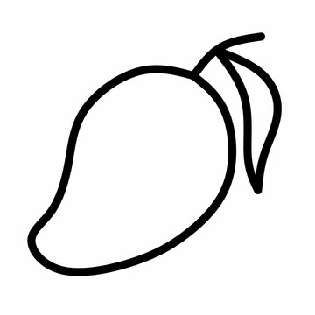
- Class Test. (5)
- Handwriting. (2)
- Oral. (2)
- Assignment. (2)
- Discipline. (2)
- Regularity. (2)
THE END

