
Sarbanam Shikshyalaya
Gokarneshwor-06 Jorpati, Kathmandu
Final Examination-2079
Grade: Nursery F.M:50
Subject: All Subjects Oral P.M:20 Time: 1:15 hrs.
Name: Section: Roll. No:

Marks Obtained Sheet
Q.N. | O.M. | Q.N. | O.M. | Q.N. | O.M. | Q.N. | O.M. | Q.N. | O.M.
1. |  | 2. |  | 3. |  | 4. |  | 5.
6. |  | 7. |  | 8. |  | 9. |  | 10.
11. |  | 12. |  | 13. |  | 14. |  | 15.
16. |  | 17. |  | 18. |  | 19. |  | 20.

Total:
In words:

-------------- ---------------- ------------------ ------------------------
Invigilator Examiner Checked By Exam Coordinator
- What is your mother’s name? [5]
_____________________________________
- Who are you? [5]
____________________________________
- Where do you live? [5]
_____________________________________
- Tell the numbers from ‘20’ to ‘24’. [5]
_____________________________________
- Count the pictures and tell the correct numbers. [5]

X X______________

V V V V V______________

 ______________

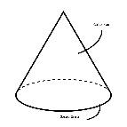
_____________

______________

- Tell the numbers from ’२०’ to ’२५’. [5]
_____________________________________

- तिम्रो आखा कति ओटा छन । [५]

_____________________________________

- ‘ट’ देखि ‘ज्ञ’ सम्म भन । [५]

_____________________________________

- तिमीलाई मनपर्ने रंग को नाम भन । [५]

_____________________________________

- तिम्रो घरमा कोको हुनुहुन्छ । [५]

_____________________________________

Sarbanam Shikshyalaya
Gokarneshwor-06 Jorpati, Kathmandu
Final Examination-2079
Grade: Nursery F.M:50
Subject: Art P.M:20 Time: 1:15 hrs.
Name: Section: Roll. No:

Marks Obtained Sheet
Q.N. | O.M. | Q.N. | O.M. | Q.N. | O.M. | Q.N. | O.M. | Q.N. | O.M.
1. |  | 2. |  | 3. |  | 4. |  | 5.
6. |  | 7. |  | 8. |  | 9. |  | 10.
11. |  | 12. |  | 13. |  | 14. |  | 15.
16. |  | 17. |  | 18. |  | 19. |  | 20.

Total:
In words:

-------------- ---------------- ------------------ ------------------------
Invigilator Examiner Checked By Exam Coordinator

- Trace the colour name. [5]

- Find the way. [5]

- Join the dots and colour it. [10]

- Draw straight lines. [5]

- _ __ _ __ _ __ ___ __ _ _ _ _ _ _ _ .

- _ __ _ __ _ __ ___ __ _ _ _ _ _ _ _ .
- _ __ _ __ _ __ ___ __ _ _ _ _ _ _ _ .
- _ __ _ __ _ __ ___ __ _ _ _ _ _ _ _ .
- _ __ _ __ _ __ ___ __ _ _ _ _ _ _ _ .

- Draw a picture of triangle and circle shapes. [10]

- Class test. [5]

- Handwriting. [2]
- Oral. [2]

- Assignment. [2]

- Discipline. [2]

- Regularity. [2]

Sarbanam Shikshyalaya
Gokarneshwor-06 Jorpati, Kathmandu
Final Examination-2079
Grade: Nursery F.M:100
Subject: Science P.M:40 Time: 2:30hrs.
Name: Section: Roll. No:

Marks Obtained Sheet
Q.N. | O.M. | Q.N. | O.M. | Q.N. | O.M. | Q.N. | O.M. | Q.N. | O.M.
1. |  | 2. |  | 3. |  | 4. |  | 5.
6. |  | 7. |  | 8. |  | 9. |  | 10.
11. |  | 12. |  | 13. |  | 14. |  | 15.
16. |  | 17. |  | 18. |  | 19. |  | 20.

Total:
In words:

-------------- ---------------- ------------------ ------------------------
Invigilator Examiner Checked By Exam Coordinator

Sarbanam Shikshyalaya
Gokarneshwor-06 Jorpati, Kathmandu
Final Examination-2079
Grade: Nursery F.M:100
Subject: English P.M:40 Time: 2:30 hrs.
Name: Section: Roll. No:

Marks Obtained Sheet
Q.N. | O.M. | Q.N. | O.M. | Q.N. | O.M. | Q.N. | O.M. | Q.N. | O.M.
1. |  | 2. |  | 3. |  | 4. |  | 5.
6. |  | 7. |  | 8. |  | 9. |  | 10.
11. |  | 12. |  | 13. |  | 14. |  | 15.
16. |  | 17. |  | 18. |  | 19. |  | 20.

Total:
In words:

-------------- ---------------- ------------------ ------------------------
Invigilator Examiner Checked By Exam Coordinator

- Write down from ‘T’ to ‘X’. [10]
- Change the following small letters into capital letters. [5]

g ________________

h ________________

i ________________

j ________________

k ________________

- Match the following. [10]

a c

b d

c a

d e

e d

- Join the dots and complete the words. [10]

- Fill in the missing letters. [5]

K _________ M ___________ O ___________ Q

_____________S ____________ U


- Write the first letter of the given pictures. [5]
_______________

________________
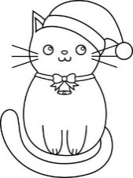
________________



________________
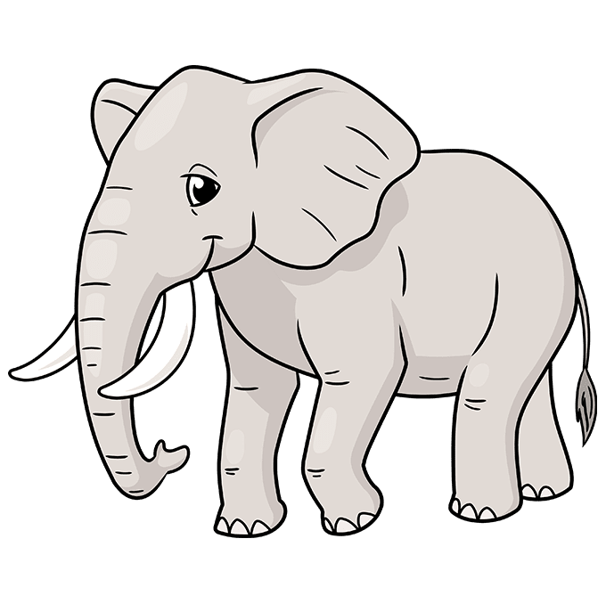

________________

- Circle the letter ‘ S’. [10]

S T U V

V U S T

U S T V

T U S V

V S U T

- Copy the following. [5]

q r s

__________ __________ ____________
t u

____________ ____________.

- Join the dots and make a word. [5]

- Class test [10]

- Handwriting. [5]

- Oral. [5]

- Assignment. [5]

- Discipline. [5]

- Regularity. [5]

Sarbanam Shikshyalaya
Gokarneshwor-06 Jorpati, Kathmandu
Final Examination-2079
Grade: Nursery F.M:100
Subject: Math P.M:40 Time: 2:30 hrs.
Name: Section: Roll. No:

Marks Obtained Sheet
Q.N. | O.M. | Q.N. | O.M. | Q.N. | O.M. | Q.N. | O.M. | Q.N. | O.M.
1. |  | 2. |  | 3. |  | 4. |  | 5.
6. |  | 7. |  | 8. |  | 9. |  | 10.
11. |  | 12. |  | 13. |  | 14. |  | 15.
16. |  | 17. |  | 18. |  | 19. |  | 20.

Total:
In words:

-------------- ---------------- ------------------ ------------------------Invigilator Examiner Checked By Exam Coordinator

- Write down ‘26’ to 30. [10]

____________ ____________ ____________

____________ ____________.

- Write down from ’२६’ to ‘३०’. [10]

____________ ____________ ____________

____________ ____________.

- Join the dots and make number. [5]

- Count and write the numbers. [10]



_________________.


________________.

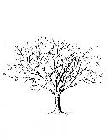 _________________.



__________________.
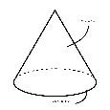__________________________.
- Fill in the blanks. [5]

1 _________ 3 _______ 5 ___________

7 ________ 9 _________ 11

- Circle the number ‘ ११’ . [10]

११ १२ १३ १४

१४ १३ ११ १२

१३ ११ १४ १२

१२ १३ १४ ११

१४ ११ १२ १३
- Match the same numbers. [10]

11 12

12 11

13 15

14 13

15 14

- Copy the following. [5]

२० २१ २२

______________ ______________ ____________

२३ २४

__________________ __________________

- Class test. [10]

- Handwriting. [5]

- Oral. [5]

- Assignment. [5]

- Discipline. [5]

- Regularity. [5]

;j{gfd lzIffno
uf]s0f]{Zj/-)^,hf]/kf6L
jflif{s k/LIff —@)&(

sIff M g;{/L k"0ff{ª\s M !)) ljifo M g]kfnL pQL0ff{ª\SmM$)
;do : @ M#)3
gfd M ju{ M /f]n g M +
Marks Obtained Sheet
Q.N. | M.O | Q.N. | M.O | Q.N. | M.O | Q.N. | M.O | Q.N. | M.O
1. |  | 2. |  | 3. |  | 4. |  | 5.
6. |  | 7. |  | 8. |  | 9. |  | 10.
11. |  | 12. |  | 13. |  | 14. |  | 15.
16. |  | 17. |  | 18. |  | 19. |  | 20.

Total :
In words:

------------------ --------------- ----------------- -------------------------
Invigilator Examiner Checker Exam Co-ordinator
Students are required to
k|Zg=!= o b]lv z ;Dd n]v . -@)_

k|Zg=@= c blv p ;Dd n]v . -!)_
k|Zg=#= lrq x]/]/ klxnf] cIf/ n]v . -%_

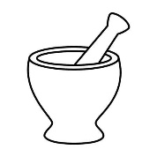
==============================

=================================
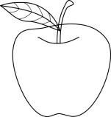
==============================


=============================

===============================

k|Zg=$= vfnL 7fpF e/ . -%_
6 ============== ====== 8 ============= =======0f
p ============== ====== C =============== ====P]
================== cf}
k|Zg=%= laGb'x? hf]8]/ zAb agfpm . -!)_
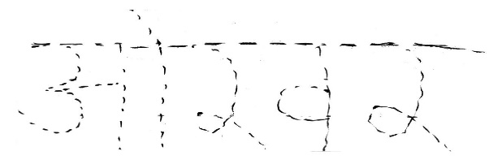
\

k|Zg=^= cIf/ / lrqsf] hf]8f ldnfpg'xf];\ . -%_
v

s
u
3
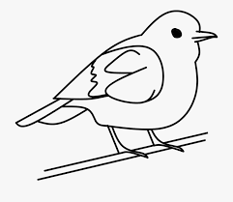
r

k|Zg=&= 1 cIf/df uf]nf] -)_ 3]/f nufpm . -%_

x If q 1
1 q If x
If x q 1
q 1 x If
If q 1 x
k|Zg=*= x]/]/ ;f/ . -%_
s | v | u | 3 | ª

k|Zg=(=PsfO{ k/LIff -!)_
k|Zg=!)=x:tn]vg -%_
k|Zg=!!=u[xsfo{{ -%_
k|Zg=!@=cg'zf;g -%_
k|Zg=!#=lgoldttf -%_
k|Zg=!$=df}lvs pQ/ -%_

Sarbanam Shikshyalaya
Gokarneshwor-06 Jorpati, Kathmandu
Final Examination-2079
Grade: Nursery F.M:100
Subject: Science P.M:40 Time: 2:30hrs.
Name: Section: Roll. No:

Marks Obtained Sheet
Q.N. | O.M. | Q.N. | O.M. | Q.N. | O.M. | Q.N. | O.M. | Q.N. | O.M.
1. |  | 2. |  | 3. |  | 4. |  | 5.
6. |  | 7. |  | 8. |  | 9. |  | 10.
11. |  | 12. |  | 13. |  | 14. |  | 15.
16. |  | 17. |  | 18. |  | 19. |  | 20.

Total:
In words:

-------------- ---------------- ------------------ ------------------------
Invigilator Examiner Checked By Exam Coordinator
- Copy down. [10]

K L M

_________ _________ __________

N O

__________ ______________

- Join the dots and complete the word. [5]

- Fill in the blanks. [5]

p ____________ r___________ t ___________

v ____________ x ____________ z.
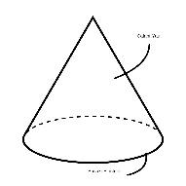
- Match the same picture. [5]



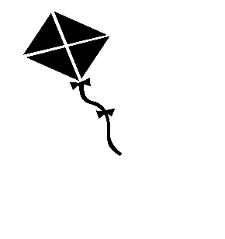



- Colour the picture. [5]


- Circle the odd one. [10]



- Join the dots and colour them. [10]

- Match the same letters. [10]

F g
G f
H I
I h
J j

- Fill in the missing part. [5]

- Class test. [10]

- Handwriting. [5]

- Oral. [5]

- Assignment. [5]

- Discipline. [5]

- Regularity. [5]

Sarbanam Shikshyalaya
Gokarneshwor-06 Jorpati, Kathmandu
Final Examination-2079
Grade: Nursery F.M:50
Subject: Theme P.M:20 Time: 1:15hrs.
Name: Section: Roll. No:

Marks Obtained Sheet
Q.N. | O.M. | Q.N. | O.M. | Q.N. | O.M. | Q.N. | O.M. | Q.N. | O.M.
1. |  | 2. |  | 3. |  | 4. |  | 5.
6. |  | 7. |  | 8. |  | 9. |  | 10.
11. |  | 12. |  | 13. |  | 14. |  | 15.
16. |  | 17. |  | 18. |  | 19. |  | 20.

Total:
In words:

-------------- ---------------- ------------------ ------------------------
Invigilator Examiner Checked By Exam Coordinator
- Colour the picture. [10]

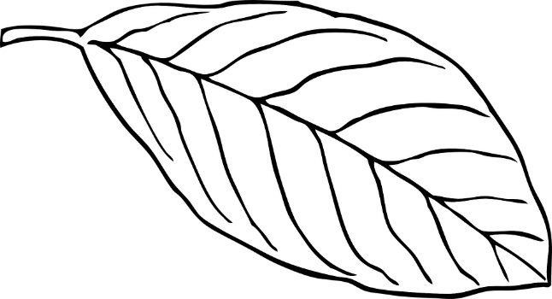

- Join the dots. [5]

- Match the same letters. [5]

M N

N M

O Q

P O

Q P
- Copy the letters. [5]

A B C

____________ ____________ ____________

D E

____________ ____________
- उस्तै अक्षरमा जोड़ा मिलाऊ । [५]

च छ

छ च

ज झ

झ ज

म म

- Copy down. [5]

6 7 8

____________ ____________ ____________

9 10

____________ ____________

- Class test. [5]

- Handwriting. [2]

- Oral. [2]

- Assignment. [2]

- Discipline. [2]

- Regularity. [2]

